ANNUAL HOLIDAY GATHERING
6th Brent Hall Award Nomination

The Brent Hall Award is given each year by the Evergreen Chamber of Commerce to honor a person whose life exemplifies a spirit of giving, community and business leadership, volunteerism, and advocacy for and support of others. The Selection Committee consists of Chamber representatives.

The Brent Hall recipient is awarded $500 from the Evergreen Chamber of Commerce to be donated to a nonprofit of their choice.

Information about Nominee

Name:

Address:

Occupation:

Information about Nominator

Name:

Contact Phone Number:

Email Address:

Relationship to Nominee:

On the following form, please write a brief description of the reasons you believe your nominee deserves to be recognized as the recipient of the 6th Brent Hall Award.

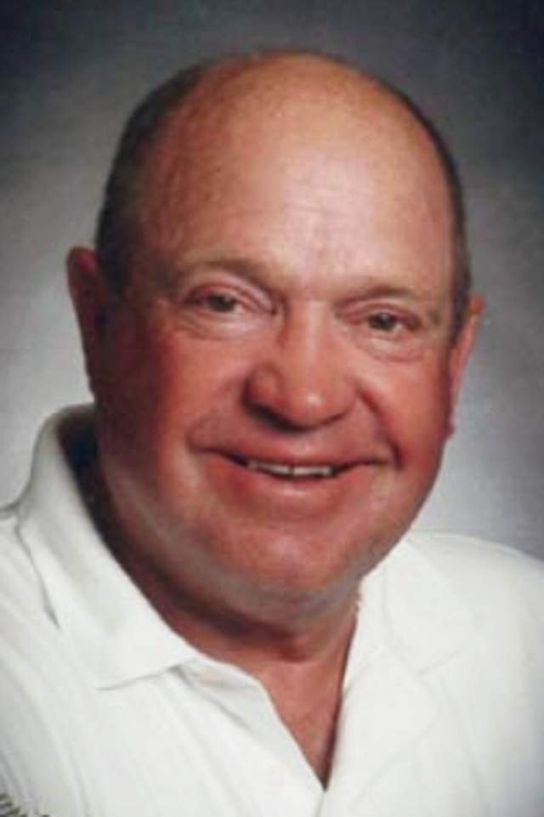

6th Brent Hall Award Nomination
Return Form to:
director@evergreencofc.com
Evergreen Chamber of Commerce
P. O. Box 5604, Kalispell, MT 59903
or submit form on our website www.evergreencofc.com

Deadline for submitting forms: 5:00 pm, Monday, November 14th, 2022

Considerations may include Leadership; Spirit of Giving and Volunteerism

Please provide additional information you believe is important for the selection committee to consider: letters of support, media reports, and other items.

______________________________________________________________________________________________________________________________________________________________________________________________________________________________________________________________________________________________________________________________________________________________________________________________________________________________________________________________________________________________________________________________________________________________________________________________________________________________________________________________________________________________________________________________________________________________________________________________________________________________________________________________________________________________________________________________________________________________________________________________________________________________________________________________________________________________________________________________________________________________________________________________________________________________________________________________________________________________________________________________________________________________________________________________________________________________________________________________________________________________________________________________________________________________________

